Exercise 18-1

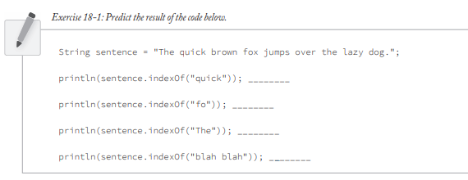

1. 4
2. 16
3. 0
4. -1